//Write a Code to Perform simple calculator operations by getting 2 numbers from users.

//[addition,subtraction,multiplication,division,Quotient,Remainder]

import java.util.*;

public class arithmetics{

public static void main(String[] args){

Scanner scan = new Scanner(System.in);

System.out.println("Enter the two numbers: ");

int num1=scan.nextInt();

int num2=scan.nextInt();

System.out.print("\nAddition: "+(num1+num2));

System.out.print("\nSubtraction: "+(num1-num2));

System.out.print("\nMultiplication: "+(num1*num2));

System.out.print("\nDivision-----\nQuotient: "+(num1/num2)+"\nRemainder : "+num1%num2);

}

}

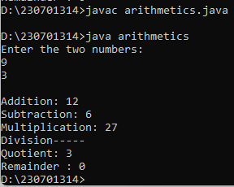

/*Write a Java program to print &#39;Hello&#39; on screen and your name on a

separate line.

Hello

Alexandra Abramov*/

import java.util.*;

public class Hello{

public static void main(String[] args){

Scanner scan=new Scanner(System.in);

System.out.println("Enter your name below:");

String name= scan.nextLine();

System.out.println("\n\nHello,\n"+name);

}

}

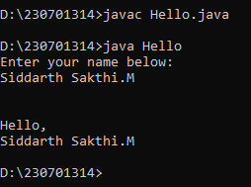

/*Write a Java program that takes a number as input and prints its

multiplication table up to 10.

Test Data: Input a number: 8 Expected Output :

8 x 1 = 8

8 x 2 = 16

8 x 3 = 24

...

8 x 10 = 80

*/

import java.util.*;

public class Tables{

public static void main(String[] args){

Scanner scan=new Scanner(System.in);

System.out.println("Enter the number: ");

int num=scan.nextInt();

System.out.println(num+" x 1 ="+num*1+"\n"+num+" x 3 ="+num*3+"\n"+num+" x 4 ="+num*4+"\n"+num+" x 5 ="+num*5+"\n"+num+" x 6 ="+num*6+"\n"+num+" x 7 ="+num*7+"\n"+num+" x 8 ="+num*8+"\n"+num+" x 9 ="+num*9+"\n"+num+" x 10 ="+num*10);

}

}

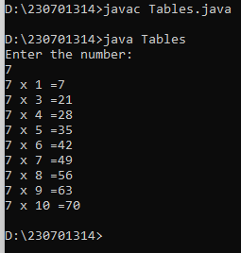

/*10. Write a Java program to compare two numbers.

Input Data:

Input first integer: 25 Input second integer: 39

Expected Output

25 != 39

25 < 39

25 <= 39*/

import java.util.*;

public class compare{

public static void main(String[] args){

Scanner scan=new Scanner(System.in);

System.out.println("Enter the two integers: ");

int num1=scan.nextInt();

int num2=scan.nextInt();

if(num1==num2)

System.out.println(num1+" = "+num2);

else if(num1>num2)

System.out.println(num1+" != "+num2+"\n"+num1+" > "+num2+"\n"+num1+" >= "+num2);

else

System.out.println(num1+" != "+num2+"\n"+num1+" < "+num2+"\n"+num1+" <= "+num2);

}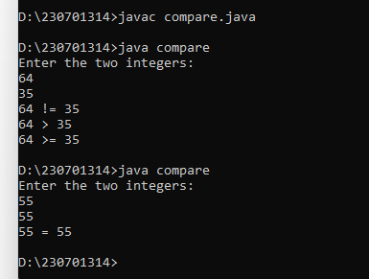

public class lpatt{

public static void main(String[] args){

System.out.println("jjjjj aaaaa v v aaaaa\n j a a v v a a\n j aaaaaaa v v aaaaaaa\n j a a v v a a\njjjjj a a v a a");

}

}

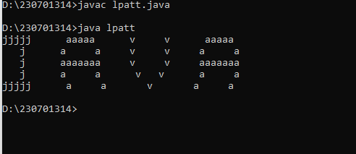

/*Write a Java program to compute the specified expressions and print

the output.

Test Data:

((25.5 * 3.5 - 3.5 * 3.5) / (40.5 - 4.5))

Expected Output

2.138888888888889

*/

import java.util.*;

public class formula{

public static void main(String[] args){

Scanner scan=new Scanner(System.in);

System.out.println("Enter 4 numbers to calculate with the formula: ");

System.out.println("(a*b-b*b)/(c-d)");

double a = scan.nextDouble();

double b = scan.nextDouble();

double c = scan.nextDouble();

double d = scan.nextDouble();

System.out.println((a*b-b*b)/(c-d));

}

}

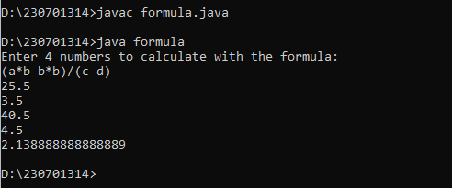

Not working yet

//9. . Write a Java program to print a face.

public class face{

public static void main(String[] args){

System.out.println(" .-""""""-.\n / _ _ \\n | (o) (o) |\n | \_/ |\n \ \_____/ /\n '-._____.-'");

}

}

/*

.-""""""-.

/ _ _ \

| (o) (o) |

| \_/ |

\ \_____/ /

'-._____.-'

*/